- Complete the table
Name:  Teacher : | ____________________________________  ______________________ |  | Date:_________
 | Year 9 Essentials – Investigation 1  Scientific Notation- Validation  Weighting % | Mark _________

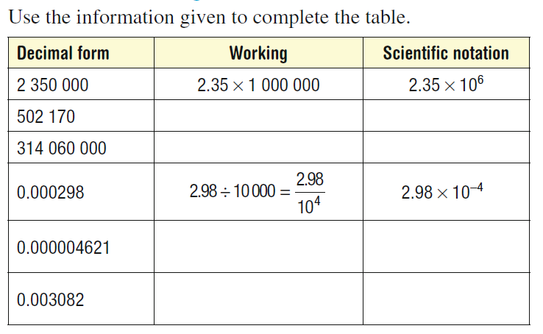

What do you notice about scientific notation form? How do you know it is correctly in scientific notation?

- Complete the table.

Scientific Notation | Working | Decimal Form
$$5.34×10^7$$
$$7.4×10^5$$
$$4.25×{10}^{-6}$$
$$3.02×{10}^{-10}$$

- Put the following in ascending order (smallest to largest)

- $8×{10}^{5}, 8×{10}^{4}, 8×{10}^{3}$

- $5.3×{10}^{-3}, 6.2^×{10}^{-3}, 8×{10}^{-6}$

- $6300 , 3.4×{10}^{4}, 8×{10}^{3}$

When ordering numbers in scientific how do you know one number is larger than the other?

- Simplify the following expressing your answers in scientific notation

- ${\left(8×{10}^{4}\right)}^{2}$

- $(3.4×{10}^{4})×(2×{10}^{3})$

- $(9.3×{10}^{6})÷(3.1×{10}^{4})$

- Which of the following is the correct way to represent 470 000 in scientific notation?

- $47×{10}^{4}$

- $4.7×{10}^{5}$

- In question 5, one of the previous answer is correct. What is wrong with the incorrect answer? Why is it not in scientific notation?

